| **Job Sheet** |
| --- |

| **Module** | **:** | IoT Fundamentals | **Module Code** | **:** | EC33105FP | |
| --- | --- | --- | --- | --- | --- | --- |
|  |  |  |  |  |  | |
| **Job No** | **:** | 7 | **Duration** | **:** | F/T: | 2 hours |
|  |  |  |  |  | P/T: |  |

| **Job Title** | **:** | Setup WiFi router and Interface IoT Device |
| --- | --- | --- |
|  |  |  |
| **Objectives** | **:** | 1. Setup 4G router with Data SIM |

**Tools, Equipment and Materials**

| PC |
| --- |
| 4G LTE Router |
| **Steps** |
|  |

1. Find the manual for the given router by Googling the model number. For example, the model of the router shown in the image below is MR6400.

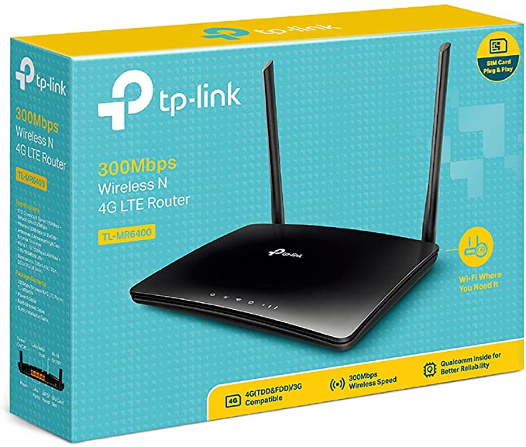

1. Search for the manual. For example, ***MR6400 manual*** will give you the manual from the vendor.

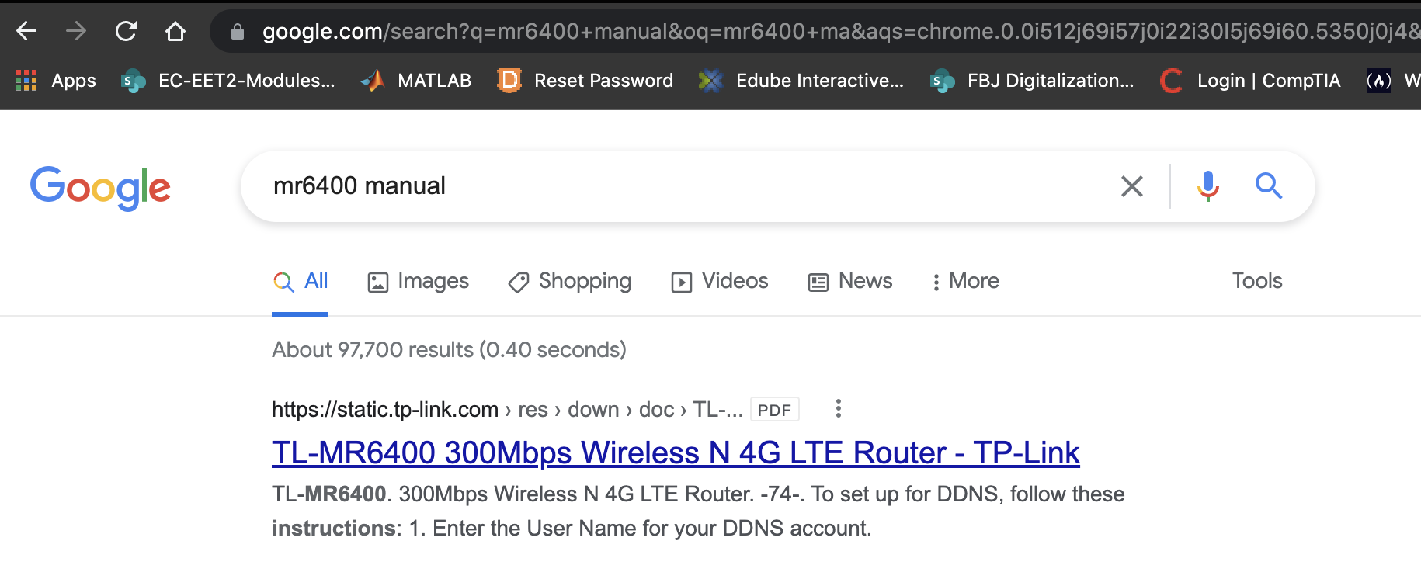

1. Follow the manual to perform the following
   1. Power On
   2. Setup SIM (if necessary)
2. Perform a Quick Setup of network (3G/4G or LAN). Name the network SSID and password/passphrase as given by your lecturer. Copy down the given details into the table below. This step will need your router to reboot.

| Network Name / SSID |  |
| --- | --- |
| Password / Passphrase |  |

1. Once your wifi network is alive, you should see your WiFi network SSID shown by using your mobile phone / PC to search for it. For example, **safeent** is the SSID used in step 5.

